Module 03 Lab 02 Laptop EDA Screenshot Evidence and Discussion
Reference label for this notebook: Lab2 (each heading below is numbered Lab2_1, Lab2_2 and so on).
This document gathers the screenshots for Module 03 Lab 02, exploratory data analysis of laptop prices, with a heading for each step from loading the data to the Pearson correlation of every attribute. The notebook uses laptop_pricing_dataset_mod2.csv, which contains 238 laptops and 16 columns including the engineered attributes from the previous module, and it follows Tasks 1 to 4 of the lab. The file name of each screenshot is printed below the image.

Lab2_1. Section 1 Downloading the prepared laptop dataset
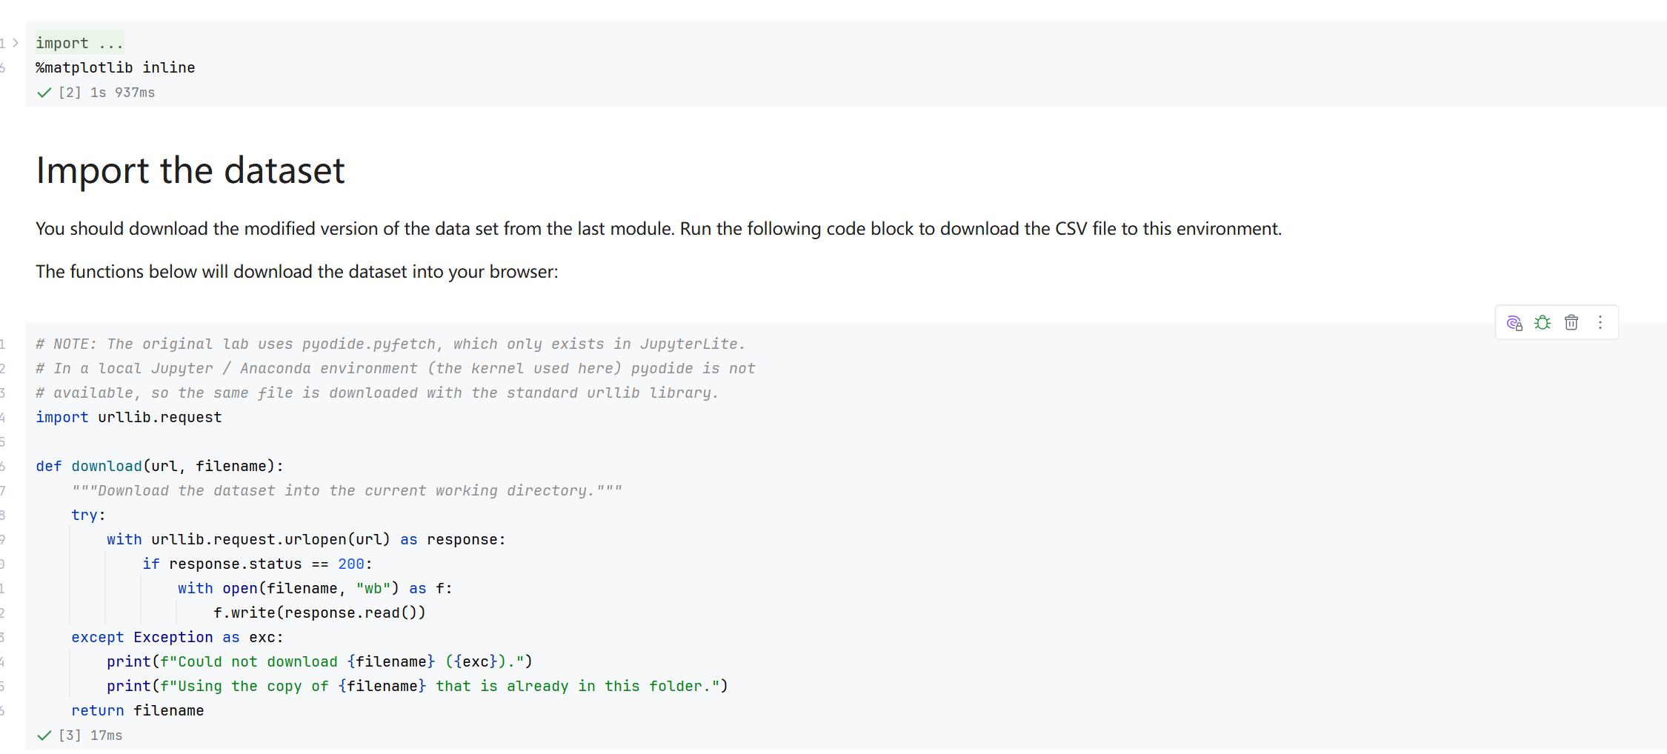
Screenshot file: 01_download_function_urllib.png
(image width 16.4 cm, scale to fit)
The download function stores laptop_pricing_dataset_mod2.csv as laptops.csv so the notebook can read the prepared dataset locally, with a fallback to the existing copy when the download fails.

Lab2_2. Section 1 Reading the dataset straight from its URL
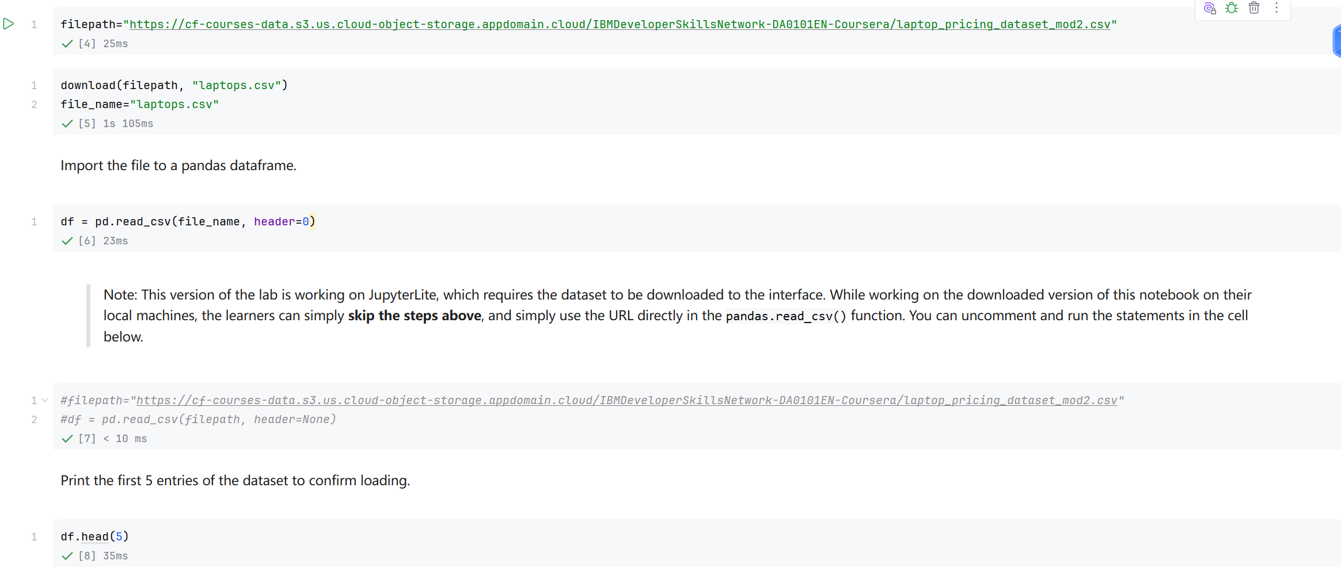
Screenshot file: 02_read_csv_url_option_commented.png
(image width 16.4 cm, scale to fit)
The alternative cell reads the same prepared CSV directly from the course URL; it is kept commented out because the local copy is already in place.

Lab2_3. Section 1 First five rows of the dataset
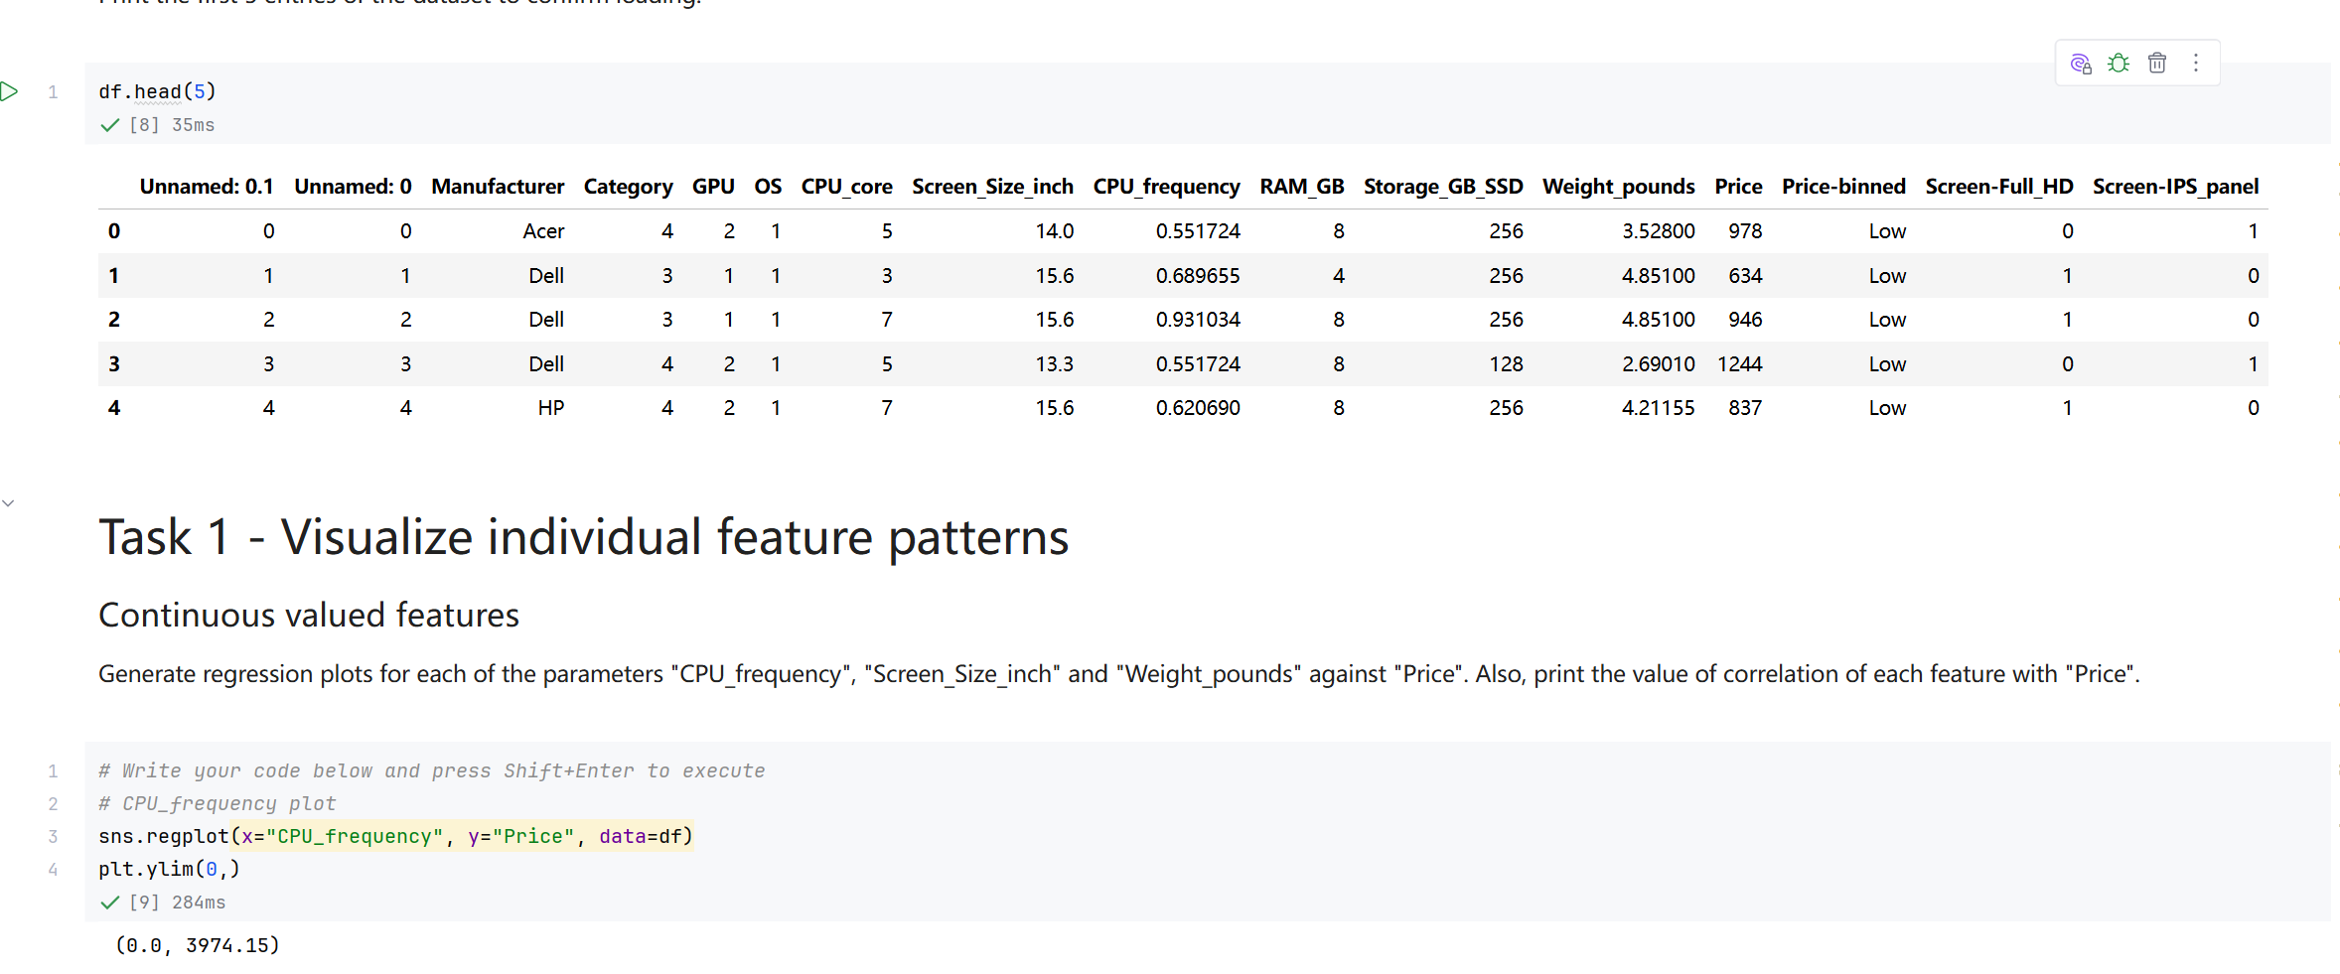
Screenshot file: 03_df.head_5&Task1_ylim.png
(image width 16.4 cm, scale to fit)
df.head(5) confirms the shape of the prepared data, which now includes Weight pounds, Price binned and the screen type indicators in addition to the original attributes.

Lab2_4. Task 1 Regression plot of price against CPU frequency
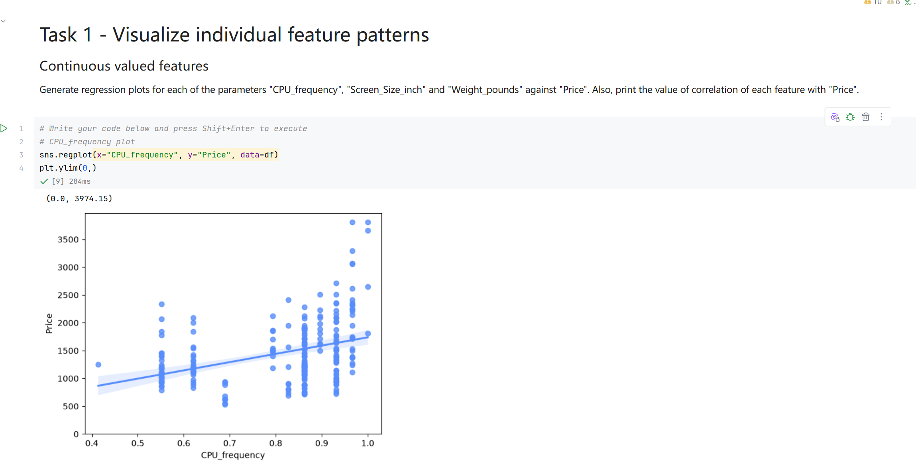
Screenshot file: 04_Task1_regplot_CPU_frequency_vs_Price.png
(image width 16.4 cm, scale to fit)
The regression plot for CPU_frequency against Price shows a positive trend, the strongest of the three continuous features tested in this task.

Lab2_5. Task 1 Regression plot of price against screen size
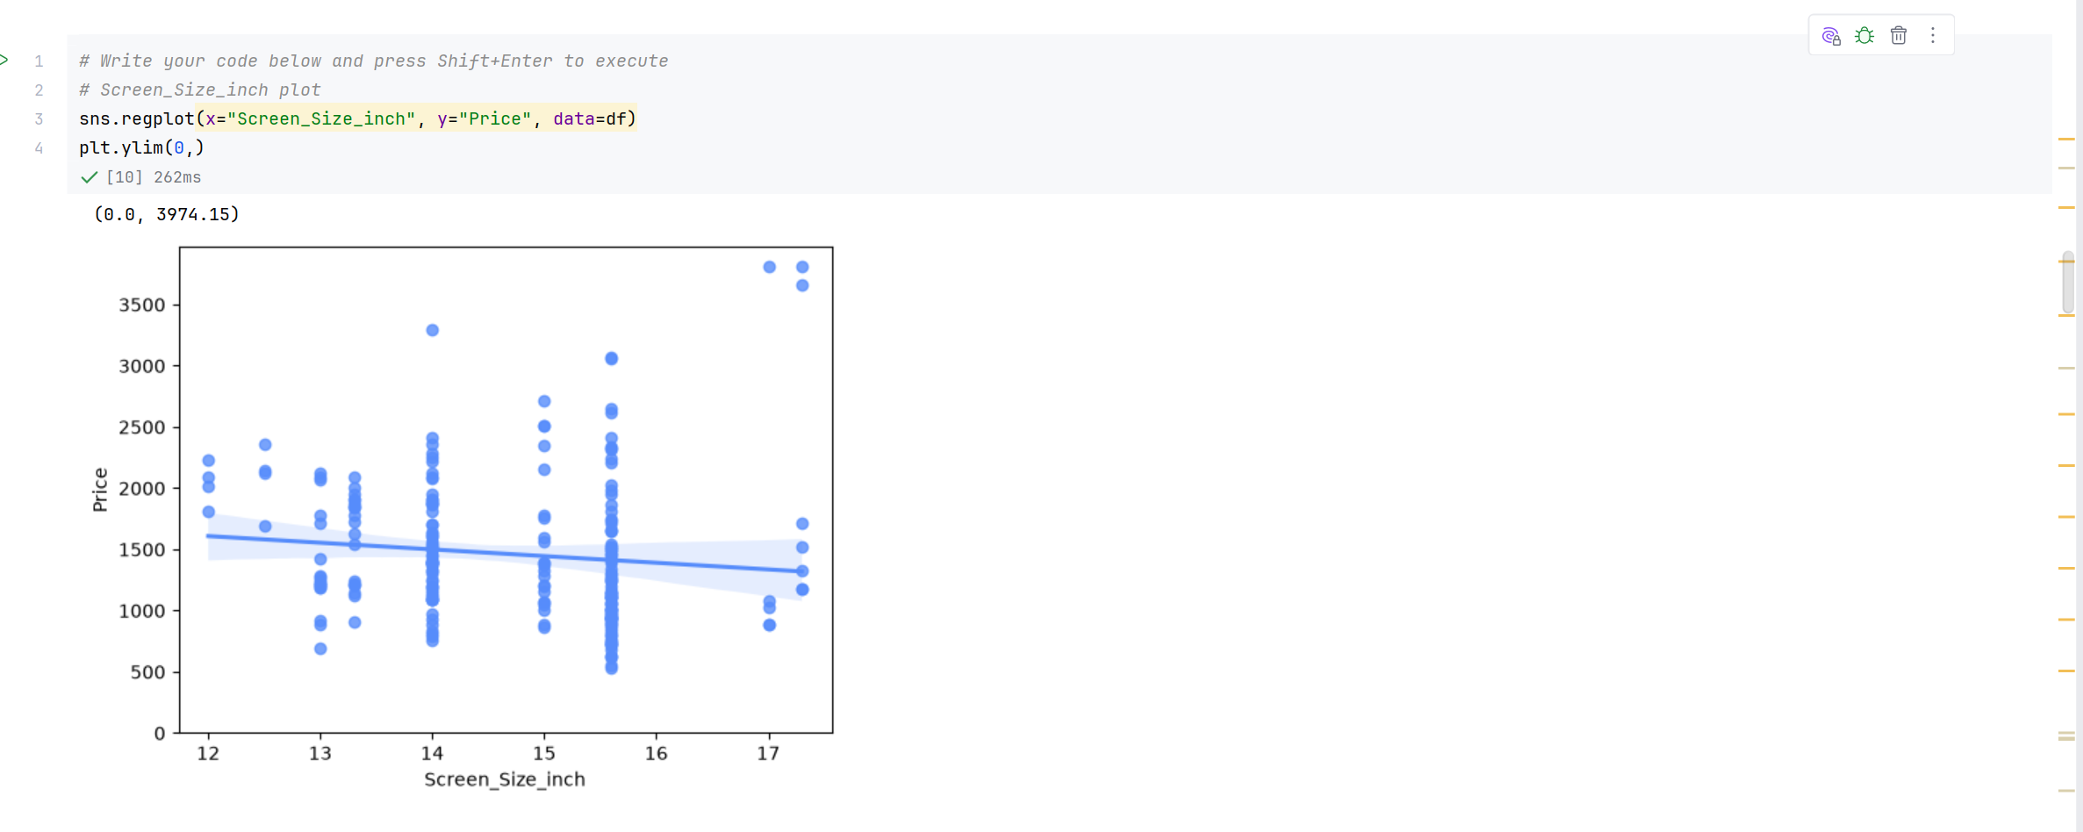
Screenshot file: 05_Task1_regplot_Screen_Size_inch_vs_Price.png
(image width 16.4 cm, scale to fit)
The plot for Screen Size inch is almost flat, indicating that screen size alone explains very little of the price variation.

Lab2_6. Task 1 Regression plot of price against weight
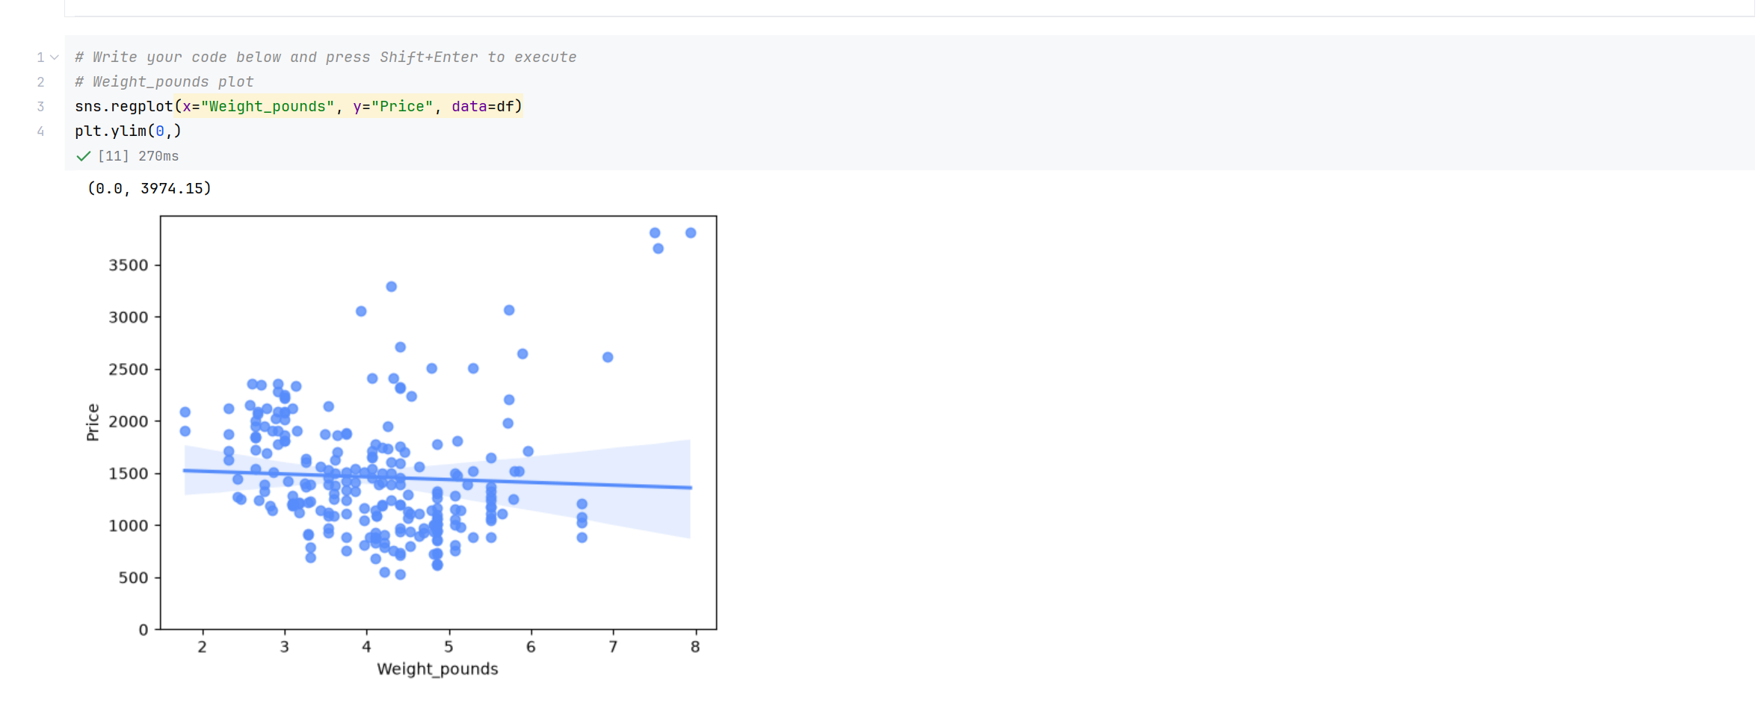
Screenshot file: 06_Task1_regplot_Weight_pounds_vs_Price.png
(image width 16.4 cm, scale to fit)
The plot for Weight pounds is also flat and slightly negative, so weight is a weak single predictor here.

Lab2_7. Task 1 Correlation of the three continuous features with price
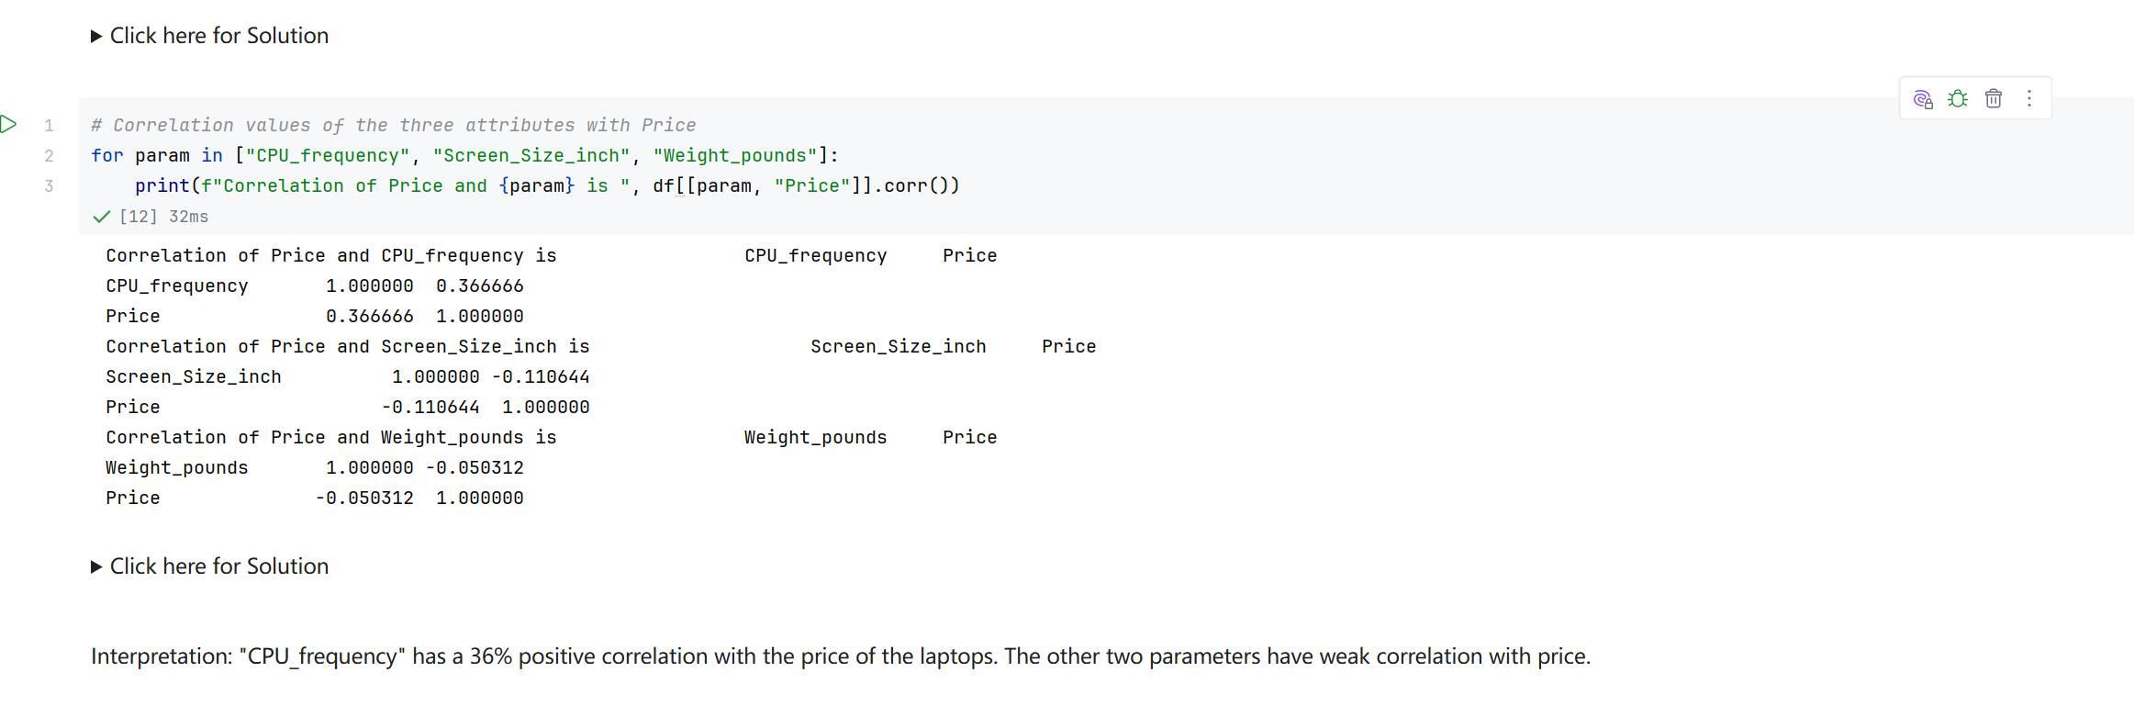
Screenshot file: 07_Task1_corr_loop_of_three_features.png
(image width 16.4 cm, scale to fit)
The loop prints the correlation of CPU frequency, Screen Size inch and Weight pounds against Price, about 0.37, -0.11 and -0.05, matching the interpretation given in the notebook.

Lab2_8. Task 2 Introduction to the categorical box plots and the first plot
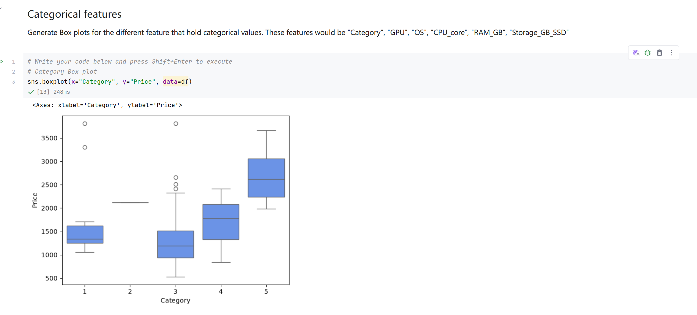
Screenshot file: 08_section_Categorical_features_and_boxplot_Category.png
(image width 16.4 cm, scale to fit)
The section text lists the categorical attributes to compare and the first box plot of Category against Price is shown.

Lab2_9. Task 2 Box plot of price by category
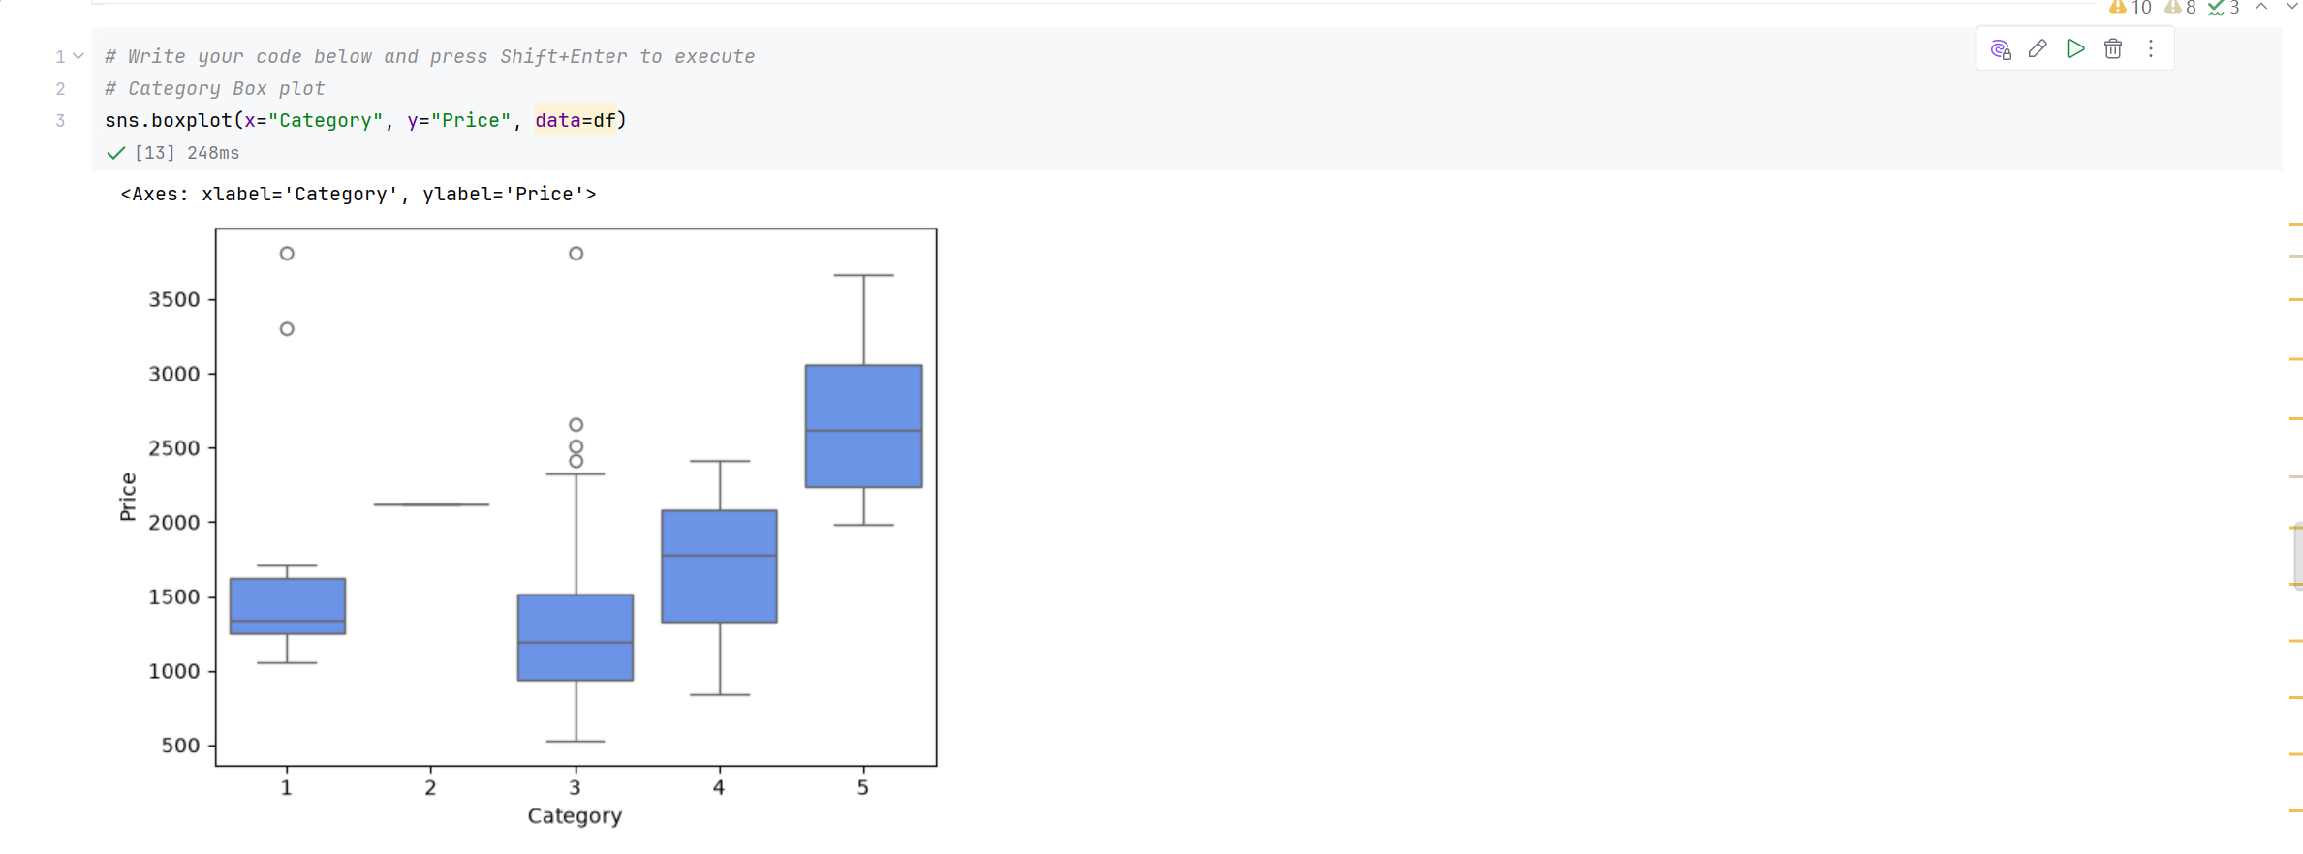
Screenshot file: 09_boxplot_Category_vs_Price.png
(image width 16.4 cm, scale to fit)
The box plot for Category shows the price distribution of each category value and where the outliers sit.

Lab2_10. Task 2 Box plot of price by GPU
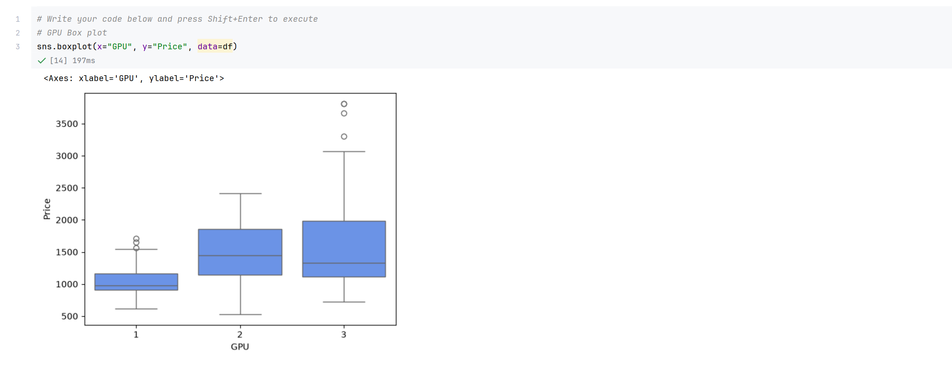
Screenshot file: 10_boxplot_GPU_vs_Price.png
(image width 16.4 cm, scale to fit)
The GPU groups are compared in the same way, with the higher GPU tiers sitting at higher median prices.

Lab2_11. Task 2 Box plot of price by operating system
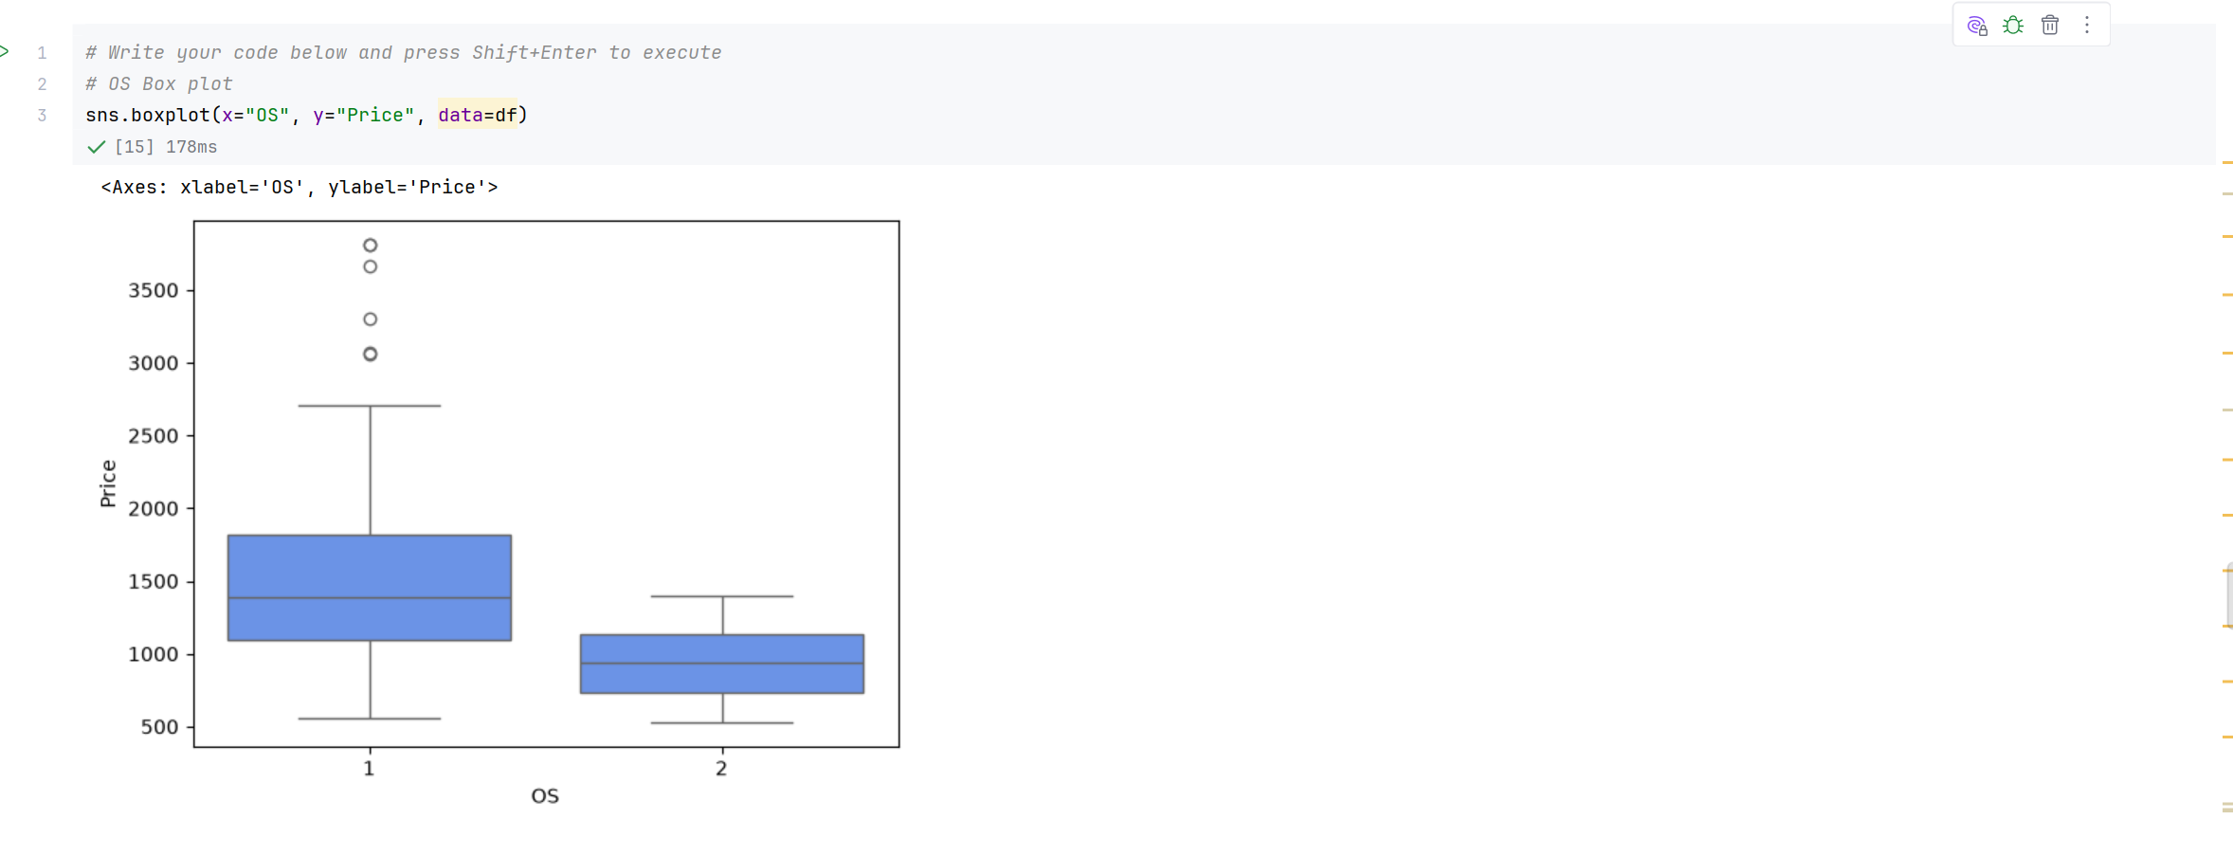
Screenshot file: 11_boxplot_OS_vs_Price.png
(image width 16.4 cm, scale to fit)
The OS comparison shows a small difference between the two systems and several high price outliers in both.

Lab2_12. Task 2 Box plot of price by CPU core count
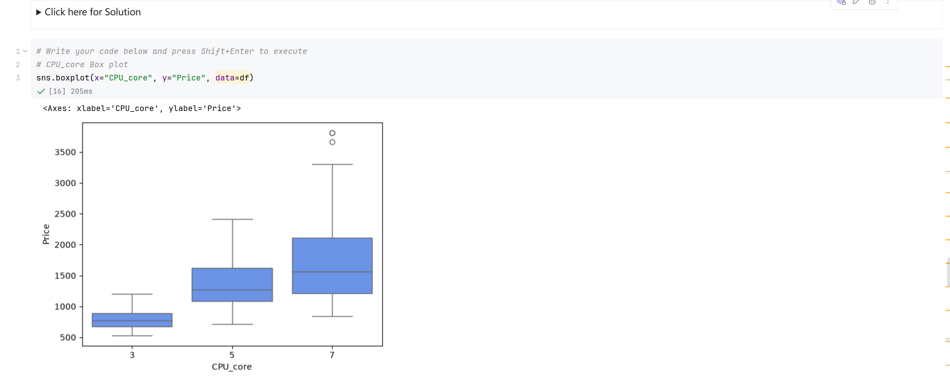
Screenshot file: 12_boxplot_CPU_core_vs_Price.png
(image width 16.4 cm, scale to fit)
The number of CPU cores separates the prices more clearly, with seven core machines well above the three core group.

Lab2_13. Task 2 Box plot of price by RAM
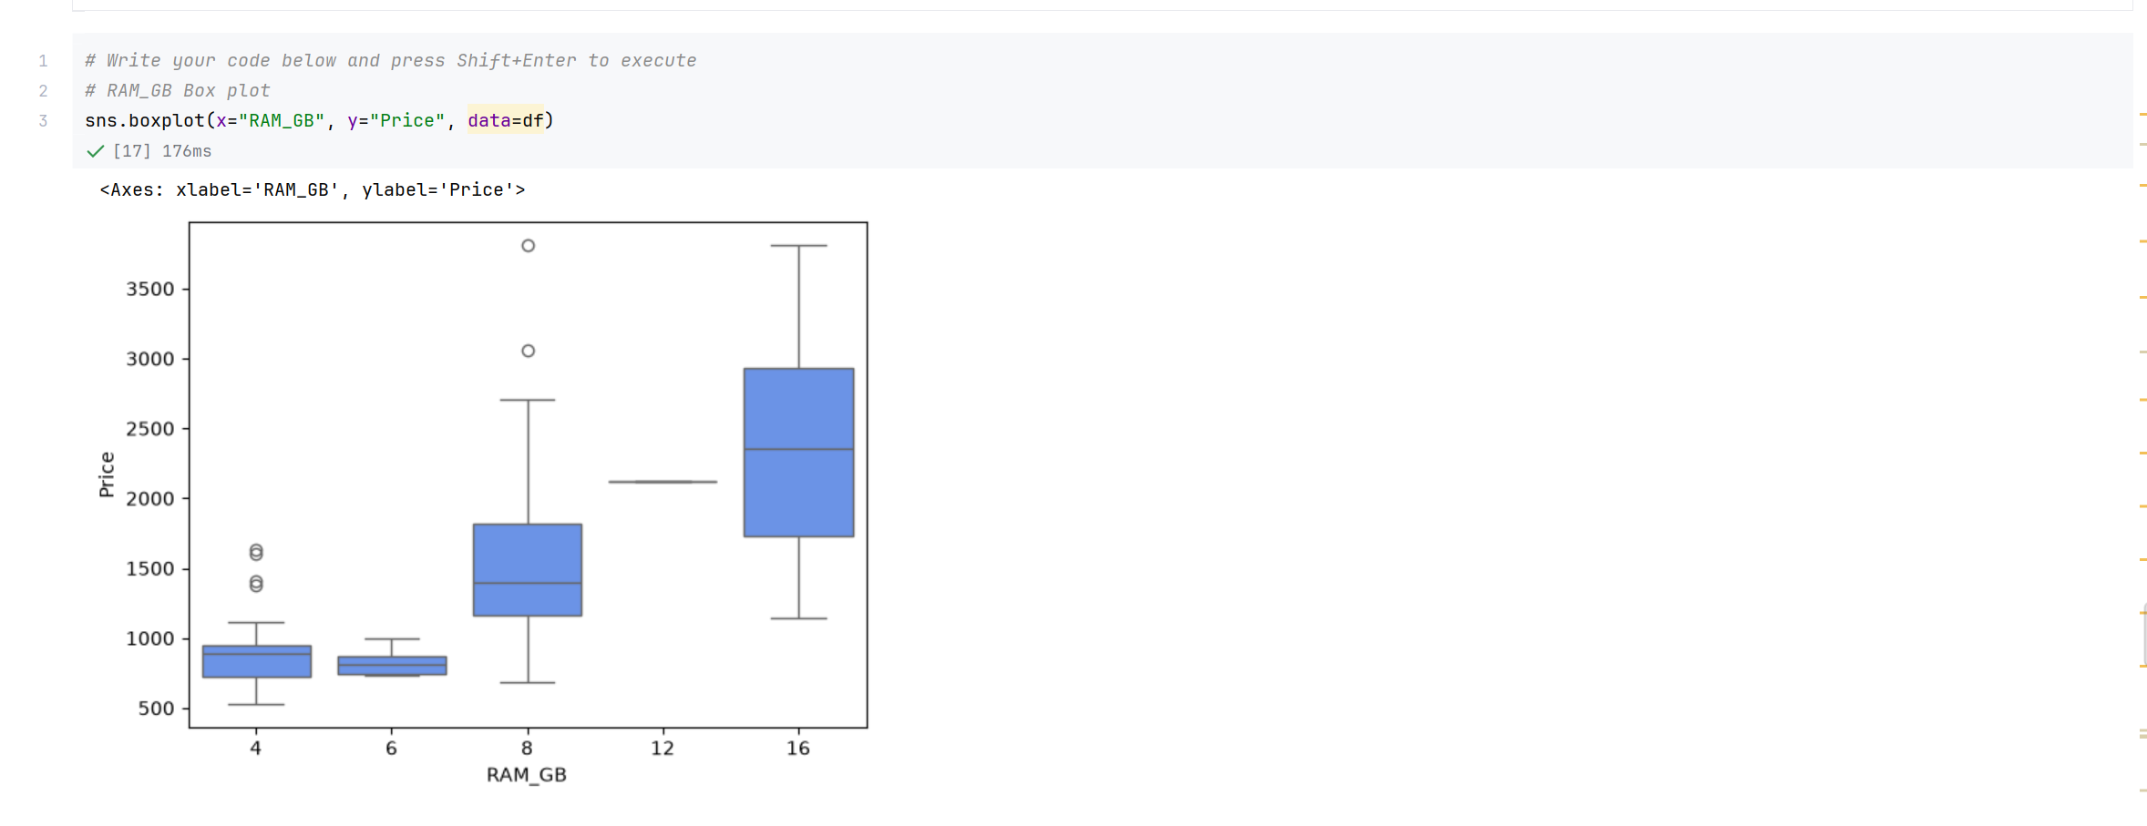
Screenshot file: 13_boxplot_RAM_GB_vs_Price.png
(image width 16.4 cm, scale to fit)
Memory size shows one of the strongest categorical separations in the dataset.

Lab2_14. Task 2 Box plot of price by SSD storage
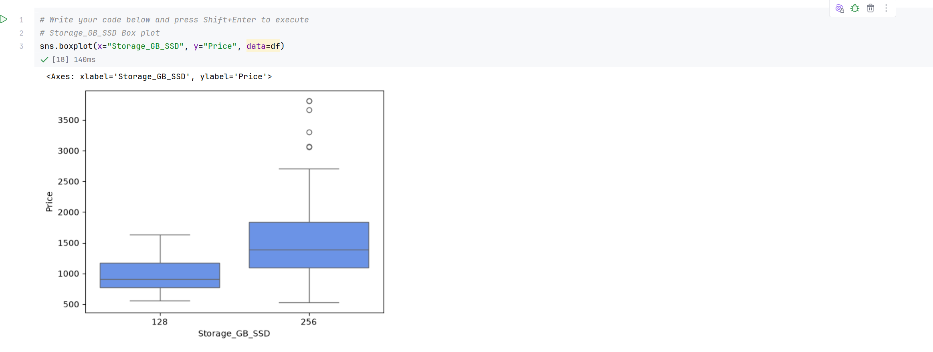
Screenshot file: 14_boxplot_Storage_GB_SSD_vs_Price.png
(image width 16.4 cm, scale to fit)
The storage comparison shows that most laptops in the sample have 256 GB and that the 128 GB machines are clearly cheaper.

Lab2_15. Task 2 Descriptive statistics of all attributes
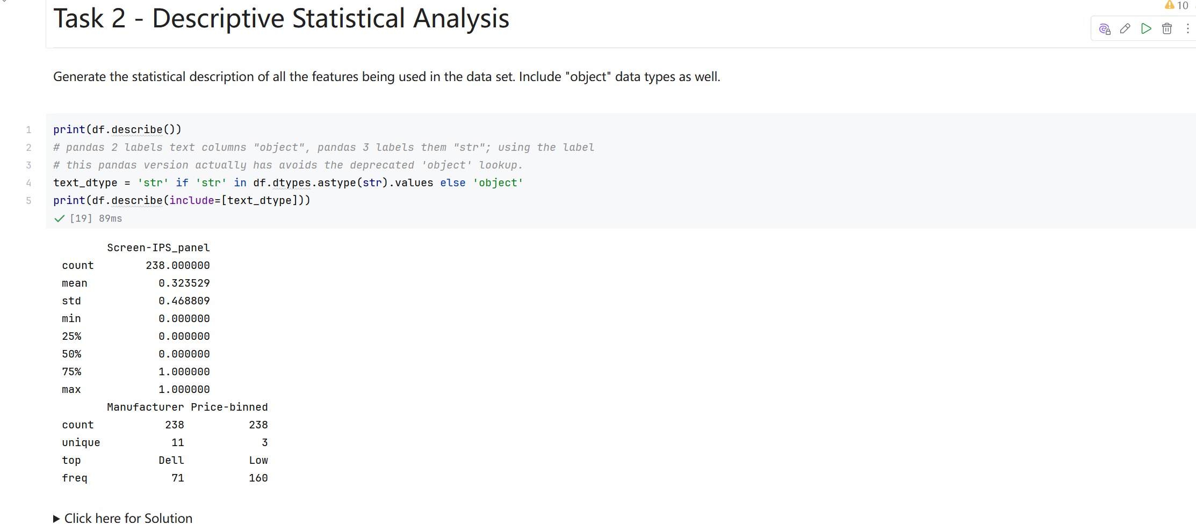
Screenshot file: 15_print_df.describe_and_describe_include_object.png
(image width 16.4 cm, scale to fit)
The describe output covers the numeric columns and then the object columns, giving an overview of the central values and of the categorical distributions.

Lab2_16. Task 3 Grouping the data by GPU and CPU cores
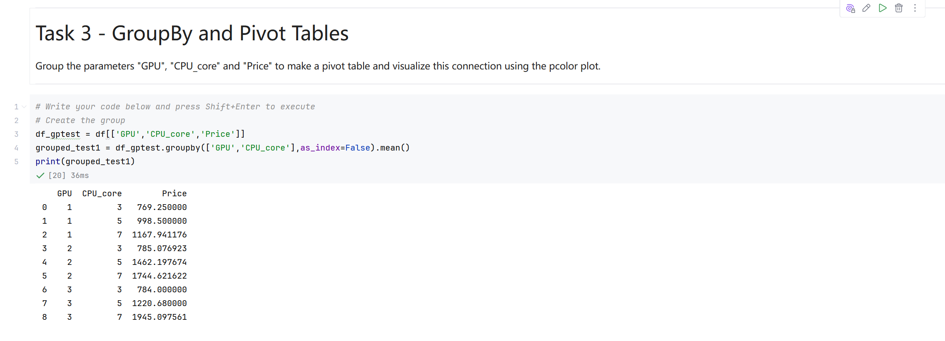
Screenshot file: 16_Task3_groupby_GPU_CPU_core_mean.png
(image width 16.4 cm, scale to fit)
df[['GPU','CPU_core','Price']].groupby(['GPU','CPU_core'], as_index=False).mean() produces the average price of every combination of graphics chip and core count.

Lab2_17. Task 3 Pivot table of the grouped prices
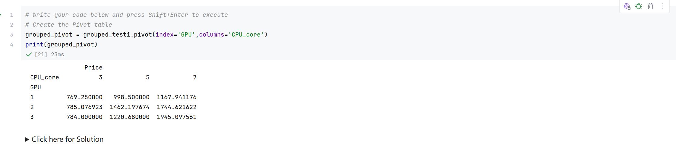
Screenshot file: 17_Task3_pivot_GPU_CPU_core.png
(image width 16.4 cm, scale to fit)
The grouped result is reshaped with pivot into a GPU by CPU core table, which is the input for the heat map.

Lab2_18. Task 3 Labelling the heat map
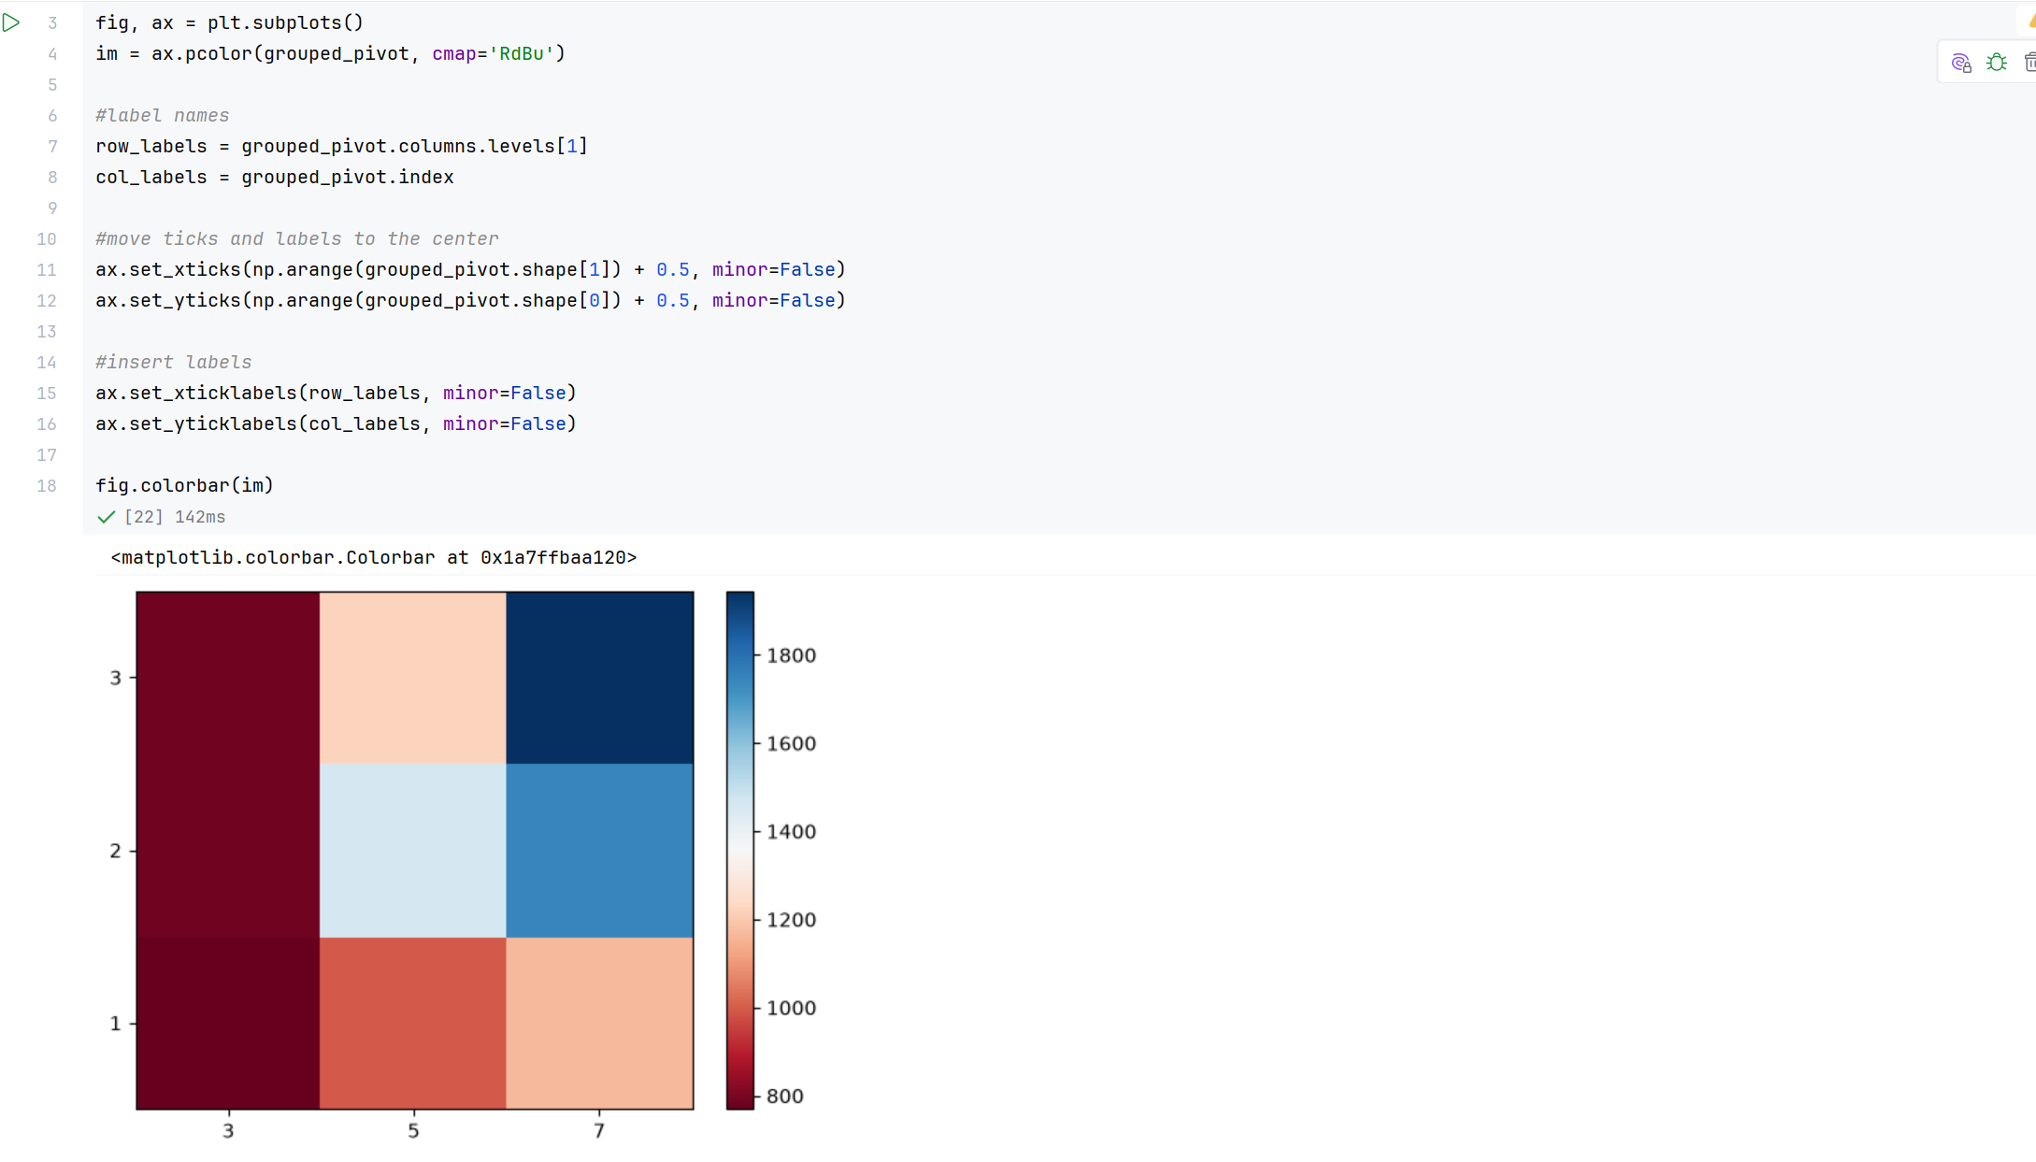
Screenshot file: 18_ax.pcolor_heatmap_with_labels.png
(image width 16.4 cm, scale to fit)
The pcolor plot is redrawn with the GPU values on the vertical axis, the core counts on the horizontal axis and a colour bar, so the price pattern can be read directly from the figure.

Lab2_19. Task 4 Pearson coefficients and p values for every attribute
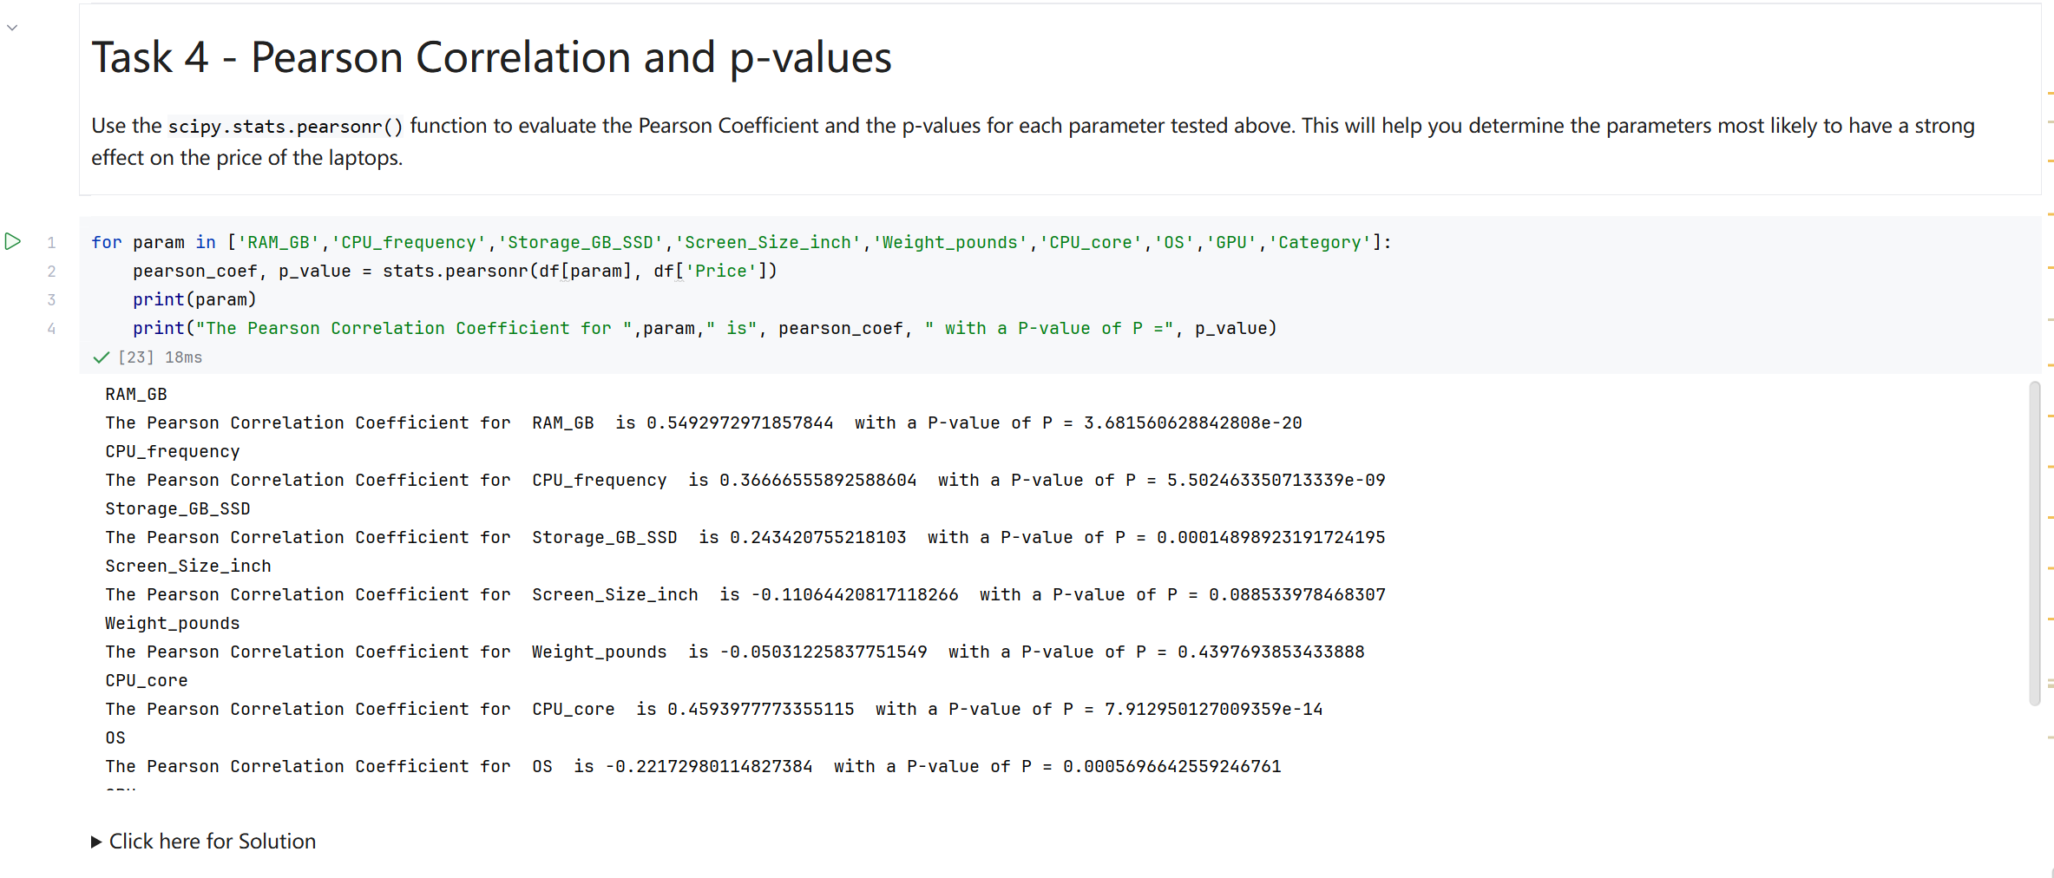
Screenshot file: 19_Task4_pearsonr_loop_9_features.png
(image width 16.4 cm, scale to fit)
The final loop runs scipy.stats.pearsonr for the nine attributes and prints the coefficient and p value for each; RAM and CPU frequency come out as the strongest numerical predictors of price.

